April 2008

Dear Sirs,

We at NCC would like to thank you for your enquiry relating to the REACh Regulation. NCC has been kept regularly informed regarding the REACh process through our membership of the European Association of Chemical Distributors (FECC) and we are aware of the REACh Regulation (1907/2006/EC), which entered into force in June 2007. NCC is committed to meeting the legal obligations under REACh, whether it be as a manufacturer, importer, distributor or downstream user and we have already begun our internal preparations to ensure compliance, insofar as that is currently possible.

As President of FECC I have personally been very active along with our team in Brussels in advocating for greater simplicity in the guidance documents to be produced under the various REACh Implementation projects. We remain very active ensuring the EU Commission and European Chemicals Agency are very aware of the detailed impacts of REACh Implementation.

We at NCC are also in close contact with our suppliers to find out their intentions regarding pre-registration and registration in order to ensure that our products remain REACh-compliant in the future.

With regard to the information on uses of the substances, the industry at European level has agreed an efficient communication process. The suppliers will propose the Exposure Scenarios for the uses that they intend to cover in their registrations at a later stage. You will then be able to verify whether your use is covered. If it is not, you will be able to assess whether you deem it confidential and therefore you intend to carry out your own safety assessment. Alternatively you will also be able to provide us with the necessary information in order to include your use. This information will be communicated in a standard format which is still under development. Please note that no information on uses is needed for the pre-registration.

We plan to ensure all materials we sell are pre registered either by ourselves or our suppliers to ensure we can avail of the phase in provisions under REACh.

Meanwhile, if you have any question, do not hesitate in contacting us.

Yours Sincerely
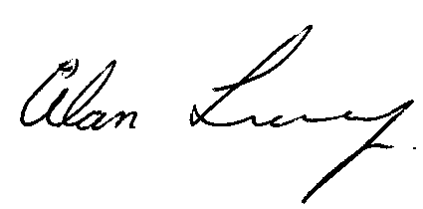
_____________
Alan Looney
Managing Director

