REACH Industry Preparation Letter Nº 11

February 2009

Use and ES development and Supply Chain Communication

Disclaimer
The information contained in REACH Industry Preparation Letter is intended for guidance only and whilst the information is provided in utmost good faith and has been based on the best information currently available, is to be relied upon at the user’s own risk. No representations or warranties are made with regards to its completeness or accuracy and no liability will be accepted for damages of any nature whatsoever resulting from the use of or reliance on the information. The guidance is based on information provided by the European Chemicals Agency and the interpretation of that information by Cefic.

Copyright
Copyright © of Cefic (AISBL), all rights reserved except for the Cefic members. No part of this publication may be reproduced, stored in a retrieval system or transmitted in any form or by any means, mechanical, photocopying, recording or otherwise, without prior written permission of the owner. Cefic claims no copyright on any official document, such as the REACH guidance documents (whose abstract may be used in this publication) or information provided by the EU Institutions and ECHA. Please apply to Mercedes Viñas (MVI@cefic.be)

Table of Content

1. Introduction 3
2. What is an Exposure Scenario? 4
3. Workflow on use and Exposure Scenario development and communication in the supply chain 6
Strategy and information collection (purple box) 7
ES development (yellow and blue boxes) 7
Communication and feedback in the supply chain (green box) 8
4. Processes for Exposure Scenario development 9
Generic and Specific Exposure Scenarios 9
Process outlines 9
Iterative approach concept 10
5. Communication with Downstream Users 12
Use and Exposure Scenario communication process 12
Alignment on Uses 12
Exposure Scenario Communication 15
Communication IT Tool 16
6. Recommended actions and communication tips 17
Recommendations for M/Is 17
Recommendations for DU associations 17
Recommendations for DUs 18
7. List of acronyms 19
Annexes 20
Annex 1: Standard format of a final Exposure Scenario for communication (Guidance on Information Requirements and Chemical Safety Assessment, part D: Exposure Scenario Building ) 20
Annex 2: Developing Generic Exposure Scenarios - Process Outline 21
Annex 3: Development of Specific Exposure Scenarios 25

1. Introduction

This Letter aims to:
- Explain the workflow for use and Exposure Scenario development;
- Explain the process for communication in the supply chain;
- Clarify the Cefic recommended tools available for:
- Exposure Scenario development
- Communication in the supply chain
- Provide guidance to Manufacturers/Importers and Downstream Users on actions required for the timely compliance with REACH requirements.

The REACH regulation sets a number of new requirements with respect to the use of chemical substances. In the Chemical Safety Assessment the Manufacturer/Importer has to demonstrate safe use of a substance for all identified uses of a substance through its whole lifecycle (manufacture, formulation, end use, service life, waste stage life). This is done by applying the proper Operational Conditions and Risk Management Measures. Considering the thousands of substances to be registered, the various uses of all these substances and the thousands of companies at each stage of the supply chain, implementation of these requirements present a major challenge and effort for all parties within the supply chain.

A common framework is necessary to harmonize communication and to support effective and efficient information exchange on uses between Manufacturers/Importers and Downstream Users in the supply chain. Standardized processes and tools for Exposure Scenario development are required to guarantee that as much uses as currently available within the supply chain are covered as identified uses with corresponding Exposure Scenarios. With these objectives, Cefic has developed a workflow and accompanying tools to meet these needs and requirements.

The development of the workflow and associated tools has been carried out in close cooperation with distributor and Downstream User organizations represented by FECC and DUCC. FECC is the European association of the chemical distribution and trading industry. The DUCC Group (Downstream Users of Chemicals Coordination Group) is a platform of eight European industry associations of companies who use chemicals for formulation of preparations and manufacture of end products. Representatives from FECC and DUCC have provided valuable contributions to workflow and tools from a distributor and DU perspective, thereby ensuring that interests of all parties involved are properly covered.

For further support and guidance of chemical companies Cefic is engaged in the preparation by VCI of a ‘practical guide’ focusing on preparing Exposure Scenarios, Chemical Safety Assessments, Chemical Safety Reports and extended Safety Data Sheets and will engage in activities aimed at harmonizing libraries for Risk Management Measures.

Cefic takes the view that this workflow for use and Exposure Scenario development and communication in the supply chain, in combination with the Exposure Scenario development and communication tools provides the essential harmonization to comply with REACH requirements in due time. On the other hand it offers the flexibility for companies to adapt them to their needs. Therefore Cefic strongly recommends that all actors in the supply chain follow this harmonized approach on Exposure Scenario development and communication as recommended in this Letter to support the timely compliance with the requirements of REACH.

Please note this Letter reflects the current status with respect to use and Exposure Scenario development as well as communication in the supply chain. Technical Guidance Documents by ECHA will be updated over time and tools for Exposure Scenario development are not finalized yet. Significant changes in requirements, guidance, processes or tools will be communicated in future Cefic publciations.

2. What is an Exposure Scenario?

Exposure Scenarios (ES) must be prepared as part of the Chemical Safety Assessment when registering substances that are manufactured or imported in quantities of 10 tonnes per year or above and that are classified as dangerous or as a PBT/vPvB substance. Furthermore, ESs should be prepared in the framework of the authorization process regardless of tonnage.

Under REACH an ES is defined as ‘the set of conditions, including operational conditions and risk management measures, that describe how the substance is manufactured or used during its life-cycle and how the manufacturer or importer controls, or recommends downstream users to control, exposures of humans and the environment. These exposure scenarios may cover one specific process or use or several processes or uses as appropriate’ (REACH Regulation, article 3-37: definition).

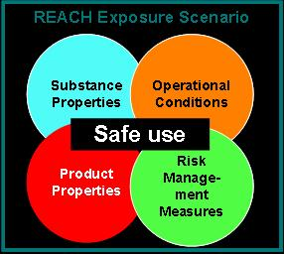
Figure 2-1: key elements of an Exposure Scenario

This definition covers a set of requirements, obligations and rights:
- An ES addresses manufacture and use of a substance. ESs have to cover manufacture and all ‘identified uses’. These are all uses by the Manufacturer/Importer (M/I) itself (e.g. formulation) and downstream uses of a substance that are supported by the manufacturer/importer.
- Any Downstream User (DU) has the right under REACH to make his use known in writing to his supplier with the aim of making this an identified use (REACH Regulation, article 37-2). Provided this is done at the latest 12 months before the registration deadline, the M/I has to take the use into account as an identified use for the Chemical Safety Assessment (CSA). DU can make a use known at any time. For uses identified after this deadline there is no guarantee that they will be considered for the registration dossier.
- For registered substances, an ES needs to be provided by the supplier either before he next supplies the substance to the DU making the request to identify a new use, provided that the request was made at least one month before the supply, or within one month after the request, whichever is the later.
- ESs have to cover all life-cycle stages resulting from these uses, including ‘service life’ and the waste life stage.
- An ES must include both Operational Conditions (OCs, e.g. production volume per hour/day, process temperature, pressure, pH, etc) and the appropriate Risk Management Measures (RMMs, e.g. containment, Local Extract Ventilation (LEV), respiratory protection) that, when properly implemented, ensure that the risks for humans and environment resulting from the uses of the substance are adequately controlled. With respect to humans this applies to control of exposure of workers in an industrial or professional setting and exposure of consumers in the private household setting. With respect to the environment this applies to control of industrial, professional and consumer emissions to water, soil and air.
- The DU is responsible for the practical details of implementation of the recommended OCs and RMMs in an ES. Implementation should take place within 12 months of receipt of the extended Safety Data Sheet (SDS) with the ES attached (REACH Regulation article 39-1).
- A DU may decide to develop his own ES when his use is not covered under the ES developed by his supplier, for any use his supplier advises against, or for a use he wants to keep confidential. In this situation the DU has to perform his own CSA within 12 months after first delivery of the eSDS and notify the European Chemical Agency (ECHA) within 6 months after receiving the eSDS.

In order to communicate OCs and RMMs that ensure safe use to DUs, ESs will be annexed to the SDS that will be supplied by M/Is of substances and formulators of products to their DUs and distributors. The Technical Guidance Document (ECHA: Information Requirements and Chemical Safety Assessment, part D) provides a structure for an Exposure Scenario (see Annex 1).

Note: there is a distinction between ESs for a substance to be registered (documented in the CSR) and ES information for products containing such a substance (preparations). The majority of products on the market are not pure substances but preparations containing a number of substances. There is no legal obligation to compile ESs for preparations. Nevertheless SDSs for preparations will contain an annex with ES information for the product. There is still a lot of discussion on adequate approaches to extract the relevant information from substance ESs to prepare ESs for products. Several methodologies have been developed and are being tested. The so-called DPD-Plus methodology is currently considered to be the best method for developing exposure scenarios for preparations (mixtures). This methodology provides guidance on the development of Exposure Scenarios for preparations (mixtures) based on selecting the ES for the leading critical substance(s) in the preparation which are driving the hazard classification according to the Dangerous Preparations Directive. Guidance on this methodology is under development and will be published on the Cefic website.

The next chapters will address the processes developed for ES development and communication.

3. Workflow on use and Exposure Scenario development and communication in the supply chain

In order to facilitate the process of ES development and communication on uses and ESs between M/I and DU in the supply chain, Cefic has developed a workflow for use and ES development and communication in the supply chain. This workflow has two goals:

- To promote the effective and efficient development of ESs through harmonized processes and supported by standardized tools.

- To provide a framework for communication between M/I and DU in the supply chain with respect to uses and ESs in order to support effective and efficient information exchange and to avoid unnecessary communication between M/I and DU.

The diagram (Figure 3-1) highlights the key elements of the workflow which are also briefly outlined in this chapter. The processes for ES development and the communication and feedback processes are addressed in more detail in the chapters 4 and 5.

The diagram contains three steps in ES development and communication:

- Determination of the strategy for information collection and ES development (purple box).
- ES development using the available ES development processes (yellow and blue boxes).
- Communication and feedback in the supply chain (green box).

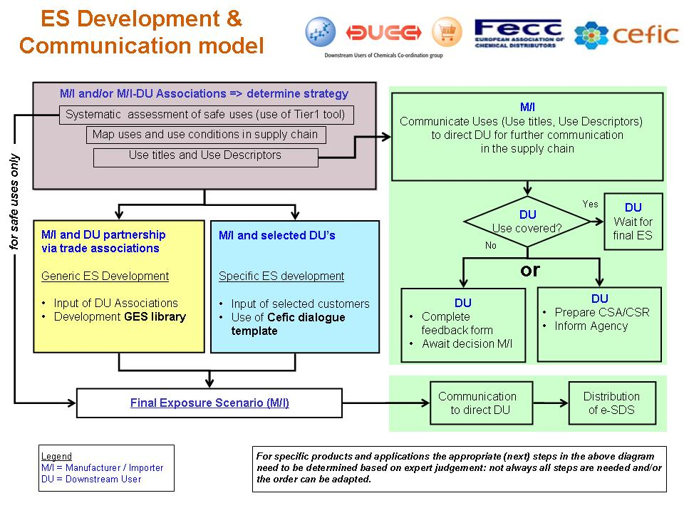
Figure 3-1. Workflow diagram for Exposure Scenario development and communication

Strategy and information collection (purple box)

The first step a M/I should take is to determine which strategy for ES development will be most effective and efficient to suit their needs and the needs of its customers best. Where a M/I has demonstrated safe use based on available in-house information and using Tier 1 assessment tools, he may decide to proceed directly to the description of Final ESs. A M/I may also decide to develop ESs based on both in-house information and available information within the supply chain. For this purpose there are two processes for development of ESs proposed, as shown in the next paragraph and further addressed in chapter 4. Which strategy to take and which (combination of) elements out of these ES development processes to use in the development of ESs is determined by factors as the number of substances and uses to be assessed, the properties of substances and their supply chains and the characteristics of and relations with DUs.

The collection of information on use and exposure is primarily undertaken in house by M/I or M/I organizations. The information collection is aimed at:

- Determination of uses which are intended to be supported (described by so called Use Descriptors and Environmental Release Categories (ERC); these will be discussed later in this chapter as well as in chapter 5).
- Generation of initial ESs and ERCs as the basis for further ES development.

Currently a number of DU associations have carried out or are carrying out a “use mapping exercise” aimed at preparing an inventory of Use Descriptors and ERCs of relevance to their sector. Such inventories contain valuable information for M/Is to confirm their understanding of the sector and to use in the preparation of ESs.

ES development (yellow and blue boxes)

In the ES development step two processes are distinguished for generation of ESs:

- The Generic Exposure Scenario (GES) process: GESs describe ESs for (groups of) substances within a general area of industry and are developed by M/Is in partnership with DU associations. GESs are to be included in GES libraries for public use within sectors.

- The Specific Exposure Scenario (SES) process: SESs describe ESs for individual substances in both specific and general uses and are developed by the M/I in dialogue with DU selected customers.

Table 3-1 provides an overview of the prime focus of the two processes for ES development.
Generic ES process | Specific ES process
Prime focus | Prime focus
M/I and DU partnership via trade organizations | M/I and selected DU customer iteration
Common uses, e.g. commodity chemicals | Specialized uses, e.g. fine chemicals
Dispersive applications | Limited supply chain
Assumes some knowledge of substance handling by M/I | Use of Cefic dialogue template when limited information on substance handling is available
Groups of substances with similar applications | Single substances with specific or general applications
Table 3-1: Prime focus of the Generic and Specific ES processes

A more detailed description of these two ES development processes and how they are interrelated can be found in chapter 4.

Communication and feedback in the supply chain (green box)

The workflow recommends communication through the complete supply chain to take place at two stages during the ES development process:

- Communication of uses, according to the Use Descriptor and ERC system, which are intended to be covered by the M/I will take place at an early stage in the Registration process. This is to provide an opportunity for DUs to determine whether their uses are covered by the M/I and if not, to communicate their use to the M/I. The uses will be communicated by a description of (provisional) Use title and Use Descriptors and ERCs according to the Technical Guidance Document (ECHA: Information Requirements and Chemical Safety Assessment, part R12 (Use Descriptor System)). Please note that this document is currently being updated. The updated version will be available in the coming months.

- Communication of the ESs intended to be published through eSDSs; this will take place at the stage of finalizing the CSA/CSR for submission to the ECHA. Communication at this stage allows the DU to evaluate his situation versus the OCs and the RMMs described in the provided ES.

The rationale for this two stage communication and the recommended options for implementation are discussed in chapter 5.

4. Processes for Exposure Scenario development

In the previous chapter, the workflow for use and ES development and communication in the supply chain has been presented. After the 'Information collection' phase the M/I may conclude that there is a need to obtain information from DU's and/or DU organisations for the ES development. There are two processes to arrive at ESs that are useful and practical for DUs and simultaneously meet the REACH registration requirements for M/Is: the Generic Exposure Scenario process and the Specific Exposure Scenario process.

Generic and Specific Exposure Scenarios

Development of Generic Exposure Scenarios (GES) is the first option. GESs describe ESs for (groups of) substances within a general area of industry. GESs are comprised of the (ESs for the) various tasks and activities that constitute the general use of the substance within a specific sector. They are particularly useful for commodity chemicals with disperse applications and/or extensive supply chains and are recommended to be developed by M/Is in partnership with DU associations.

Specific Exposure Scenarios (SES) describe ESs for individual substances in both specific and general uses. SESs can cover a set of tasks in a production or work process. They are particularly useful to develop ESs for substances with relatively short supply chains (specialty applications) or supply chains lacking well structured sector organizations. They are developed by the M/I in dialogue with DU selected representative customers.

Both processes start with collection of use and exposure information to support Tier 1 evaluation. In both processes additional targeted collection of Tier 2 data is performed where safe use is not indicated based on the Tier 1 assessment. Both processes result in the development of ESs for CSR and eSDS for DU communication. There is a subsequent need to incorporate these ESs within eSDS generation systems of M/Is.

There are also differences in approach by these processes. Table 4-1 presents a simplified outline of the stepwise approach in both processes. This outline clearly demonstrates the differences between the two processes.

Process outlines

For both processes a number of steps can be identified for development of the ES. These are shown in Table 4-1. More detailed information on each of the steps in both processes is available in Annex 2 and 3.

Generic Exposure Scenarios | Specific Exposure Scenarios
1. Compilation of an inventory of applications and mapping of associated uses (including typical OCs and RMMs) through the supply chain. Prepared initially from M/I internal sources, using a standardized mapping template. | 1. Collection of information from internal sources on uses and use conditions by M/I, using the standardized Cefic dialogue template for SES building.
2. Review of the supply chain mapping by DU organizations (adjustment of OC/RMMs). | 2. Development of initial SESs for products (containing the substance), structured along the standardized Cefic dialogue template.
3. Estimate exposure level using Tier 1 tools, e.g. ECETOC TRA (determination of required OC/ RMMs; formatting of draft GESs). | 3. Selection and approach of representative customers to provide feedback on the initial SESs and gather additional information.
4. Review of draft GESs with DU organizations to evaluate proposed OCs/RMMs. Refinement of RMMs in Tier 2 iterations, where needed, using additional exposure/emission information.  Documentation of final results of the CSA, after demonstrating safe use. | 4. Development of draft product SESs based on feedback by selected DU customers. Assignment of draft SESs to relevant substance.
5. Compilation of final GESs. Review and refinement with DU organizations, resulting in final approval. | 5. Exposure and risk assessments for each draft SES using available Tier 1 tools, e.g. ECETOC TRA. Collection of additional information, where needed, to perform a Tier 2 assessment.  Aggregation of SESs into (composite) final SESs for interconnected activities/tasks with OC/ RMMs for which safe use has been demonstrated in the CSA.
6. Definition of the application domain for each GES.  Addition of GESs to GES library for access by relevant stakeholders. | 6. Documentation of the risk assessment for the final SESs into the CSR.
7. Selection of relevant GES by M/I to support own substance registration.  Refinement of GES in the CSA as necessary to form the substance-specific ES (documentation in the M/I CSR). | 7. Transformation of substance SESs from Cefic dialogue template format to ES format for publication in eSDS of the product.
8. M/I develops and makes available product ESs for communication with and feedback from DUs pending finalization and submission of CSR and inclusion within eSDS. | 8. M/I develops and makes available product ESs for communication with and feedback from DUs pending finalization and submission of CSR and inclusion within eSDS.
Table 4-1: Outline of process steps in development of GESs and SESs.

The GES and the SES processes are not isolated from each other. For example, in the SES process GESs that have already been developed as part of GES libraries can be used as a starting point for the development of SESs. On the other hand in the GES process it is possible to utilize the Cefic dialogue template for collection of information or gaining feedback from DUs. This demonstrates that these processes on their own or in combination offer the flexibility needed by each company to develop ESs that suit their needs and the needs of their customers. Therefore Cefic strongly supports and recommends the use of the GES and SES processes for development of ESs.

Iterative approach concept

As stated above, the processes on ES development allow for flexibility. Companies can choose one of the two processes or combine them. Companies can also decide to skip steps in these processes. An example of how to apply this flexibility is the so-called iterative approach, where the initial use alignment is avoided by starting an assessment on use descriptor and ERC level (PROC, PC, ERC). The iterative approach contains three steps, which can be taken in sequence or separately, depending on the specific characteristics of a substance and its supply chain:

- A basic exposure assessment using TIER 1 assessment tools (e.g. ECETOC TRA) for all relevant uses (considering all relevant Use Descriptors and ERCs). For those uses for which safe use can be demonstrated in this first step, the related conditions of use and RMM constitute the ES.
- A generic exposure assessment step, utilizing information on uses and ESs available in the supply chain on a sectorial level for uses that were not demonstrated to be safe in the first assessment step.
- An individual exposure assessment step, in which ESs are being developed in close cooperation with individual users of products, while also utilizing in-house information.

Step 1: basic exposure assessment
Before engaging in actual collection of use and exposure information, the M/I start assessing exposure for all uses (or selected uses) of a substance, regardless of whether these uses really occur in practice. This means that for a given substance, based on available in-house information, exposure for all use options in the guidance is assessed (all Process Categories, Product Categories and Environmental Release Categories). This assessment should be carried out with an assessment tool, which is conservative enough to effectively distinguish between safe and unsafe uses, e.g. ECETOC TRA. It is assumed that a positive assessment of a use (safe use within the boundary conditions of the assessment tool) ensures adequate safety.
For uses and ESs identified as safe, one can directly proceed to describing the Final Exposure
Scenario (see Figure 3.1). For uses and ESs that are assessed as not safe for reasons of protection of human health or environment, one proceeds to step 2 or 3.

Step 2: generic exposure assessment step
For uses and ESs of a substance which are assessed as not safe in the first step, a refinement of the assessment is made, using information available at the sector level. This can be done by the M/I in different ways:

Engage in the joint activities of M/I and DU sector organizations to develop GESs.
Use GESs that are already developed within sector (e.g. GESs solvent sector).
Use information available on the websites of DU associations (results of ‘use mapping exercises’: inventories of uses within a sector based on the Use Descriptor system and ERCs).
Use of comprehensive sector-specific exposure descriptions / sector-specific packages of measures (e.g. the package developed by the German Construction Industry (GISBAU))

Based on the sector-specific information available M/I can develop substance-specific ESs for uses, assess safe use in the CSA and document the results in the CSR for registration purposes.

Step 3: individual exposure assessment step
For uses and ESs of a substance which are assessed as not safe in the first or second step, a refinement can also be made on an individual level, using the SES process. An individual exposure assessment with direct consultation of the respective customers is necessary when:

No GES information is or will become available for certain specific uses.
Insufficient sectorial information on uses is available.
Safe use cannot be demonstrated on a generic level in step 2.
Use conditions (OCs, RMMs) in the individual company differ from general sector-specific conditions
Use and use conditions are considered as confidential business information and have to be dealt with on an individual level.

5. Communication with Downstream Users

Use and Exposure Scenario communication process

During the development of Exposure Scenarios as described in Chapter 4 the communication is between M/I and DU organisations or with selected DUs. Use and ES information however needs to be communicated through the supply chain to all DUs. The elements of the communication process are described in the so called ‘green box’ (Figure 3-1). The key objectives of this communication process are:

- The DU wishes to obtain a confirmation that his specific Use of a product is covered by the Registration of the M/I.
- The DU has the right to make his Use known to the M/I.
- ES development by M/I is based on a complete list of identified Uses.
- The DU needs to be able to establish whether his Operational Conditions and the Risk Management Measures are consistent with the Exposure Scenario.

To be able to achieve these objectives there must be an alignment on both Uses covered in the registration dossier of the supplier, as well as the Exposure Scenarios associated with these Uses.

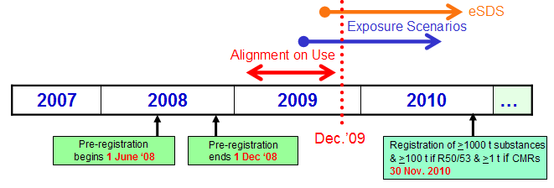
Figure 5-1: Indicative time line for the communication process between M/I and DU on Use and Exposure scenarios for substances with a registration deadline of 1 December 2010. For substances with a registration deadline in 2013 and 2018 similar communication steps need to occur. The best time to initiate this process is probably 2 years before the registration deadline.

Alignment on Uses

The alignment on Uses between M/I and DU should happen early in the Registration process, starting early in 2009 (red arrow in figure 5-1). As a result the development of the ESs will cover all applicable Uses of the substance. The alignment on Uses can occur based on tables with products a DU purchases, completed with the list of identified Uses per product (see figure 5-2 and 5-3).

The table should be customer specific, so that he only sees the products he purchases. The list will show all the products which are relevant for a customer, including products which do not require an ES, and products which have a later registration deadline and for which no Use information is available yet (indicated with ‘TBA’ (To be announced) in Figure 5-2).

The tool will allow to download the Use information, so that it can be passed on in the supply chain (e.g. by distributors). The Use should be identified by a Use title and the corresponding Use descriptors and ERCs (part of the ES short title) as per Technical Guidance Document.

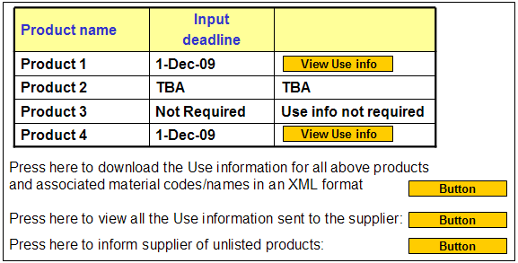
Figure 5-2: Example of a table with accompanying text that can be used to communicate from M/I to customers the Uses intended to be supported in the Registration dossiers.
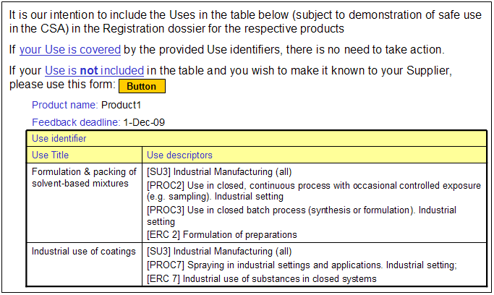
Figure 5-3: Illustration of how Use information for a certain product is displayed.

While reviewing the table of Uses supported by his supplier, the DU may find his specific use for a product is not listed. In that case the DU has the opportunity to make his use known to the supplier using a special form. The content as shown in figure 5-4 and 5-5 is based on the Use Descriptor system and the ERCs from the Technical Guidance Document.

The special form has been kept simple to provide just key information to the M/I so that he is able to evaluate whether the Use is genuinely different from what is covered in his intentions. The M/I shall consider the new Use, provided that the downstream user makes his request at least 12 months before the applicable registration deadline. As mentioned above, a DU can make a use known at any time, but this 12 months deadline has to be respected if the DU wants the M/I to consider his use in the registration. The M/I has the following options to respond:

- M/I may conclude that the Use of the substance is already covered in one of his ESs.

- M/I may conclude that the Use of the substance constitutes a manageable risk and provide a relevant ES.

- M/I may assess the Use and identify it as 'not safe' for reasons of protection of human health or environment. This must be communicated to the DU and ECHA.

- The M/I does not assess the Use (e.g. because he considers that assessment of the Use as not feasible or not economical). In this case, he should stop supplying the substance for that Use (unless the DU has performed his own CSA).

In the process of assessing a new Use made known by a DU, the M/I may actually conclude that he needs to go back to the development stage for this Use. This can then be done either via the Generic or the Specific Exposure Scenario processes described in previous chapters. It is likely that the M/I in such event will enter in a dialogue with the DU to obtain accurate information about the specific situation and the associated exposure.
If the DU decides not to make his Use known to the M/I, or the M/I has decided not to support his use as it is deemed not safe, the DU will have to develop a CSA and Exposure Assessment and inform the ECHA (see Guidance for Downstream Users), assuming he would like to continue his use.

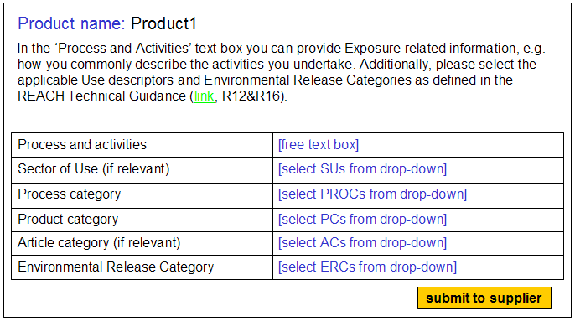

Figure 5-4: Form to be used by a DU when he finds his Use for a certain product is not covered by the Use-identifiers provided by the Supplier. Note that only a value for the relevant categories needs to be provided, and that for a certain category (e.g. SU, or PROC) multiple values can be selected if applicable.

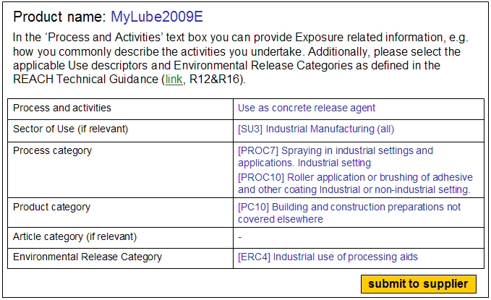

Figure 5-5: Illustration of completed input form.

Exposure Scenario Communication

When the Final ESs become available, they can be added to the table with Products and Uses (Figure 5-6). After communication to the DU's they can evaluate whether their Use is covered. These Final ESs are the ones which will be added to the extended SDSs, and therefore provide a basis for the DU to check whether his local situation is consistent with the presented OCs and/or RMMs.

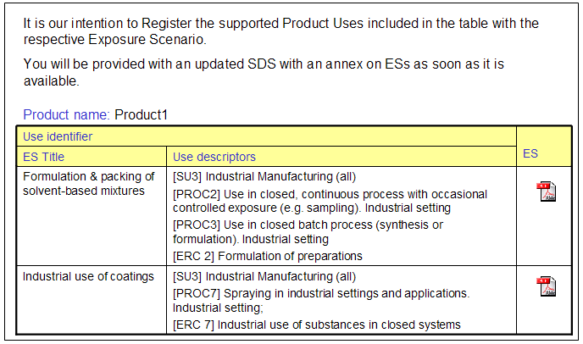
Figure 5-6: Table with accompanying text to communicate Final Exposure Scenarios from M/I to customers.

The communication of the Final ESs before it is distributed to DUs as part of the extended SDS (at the first delivery of a product after registration), has two objectives:

- The DU will have more time to implement additional RMMs, if relevant based0 on the information on RMMs in the ES;
- In case of unsupported uses the DU will have more time to select and implement alternatives for his use of the product.

It is the obligation for a DU to prepare a CSA for any Use outside the conditions described in an ES communicated to him or for any Use the M/I advises against (Article 37.4). Before developing a CSR for such situations, the DU may wish to share his OCs and RMMs with the M/I, to check whether the ES provided by the M/I can be updated. Such exceptional cases are best handled through direct communications between DU and M/I.

Communication IT Tool

Companies may find it useful to support this communication with customers using IT tools.
Cefic has developed a 'requirements' document which can be used as Technical Specification for IT providers to build the communication tool described in this chapter. This document will be made available for free to both Cefic and non-Cefic members. Key elements of the tool are:

- The tool is web-based.
- The communication is between suppliers and individual customers.
- Each Supplier has to build the tool (either by internal or external IT provider), and feed it with the relevant information.
- Communication is only with direct customers.
- Feedback can be provided via a standardized input form.
- Access is with a personal identification and password (delegation will be possible).
- Customers should be able to download the information, so that they can use it for their own communication down the supply chain (e.g. distributors).

The tool needs to be loaded with a table of products, supported uses, and ESs (when available). Additionally customer / product information needs to be provided to allow customers only to see the products he purchases. Of course it will not possible to display all the product / customer combinations in the tool. The tool will provide a report of the feed-back information provided by the customers.

It is not foreseen that the tool will be used for the communication of the final eSDS, as companies will already have their own systems to communicate these.

6. Recommended actions and communication tips

In the previous chapters the workflow for Use and ES development and communication in the supply chain with the associated ES development processes and the communication process as main elements have been explained. This chapter focuses on the actions that both M/I and DU (organizations) can undertake to ensure that:

- Communication on Use and ESs in the supply chain will be organized in an efficient and effective way (avoiding unnecessary communication and gridlock).
- M/Is can complete the CSA/CSR in time for registration purposes, covering as much of the current variety of uses as possible from a risk-based perspective.
- DUs can be confident that their use will be covered by the M/I and will have suitable product ESs available in time for their applications.

Recommendations for M/Is

- Determine which ES development strategy will be most efficient for your company, taking into account the number and type of substances/products manufactured/imported and supply chain characteristics (refer to chapter 3 and 4). It might well be possible that more than one ES development strategy is needed, considering the variety of substances and supply chains.
- Engage with (internal or external) IT providers for building/acquiring an IT tool for customer communication based on the IT ‘requirements’ document prepared by Cefic.
- Map your products using the Use Descriptor and ERC system (refer to chapter 3) for all uses you intend to register in order to prepare the Use titles for timely communication with DU customers.
- Communicate Use titles in combination with the Use Descriptors and ERCs as soon as they are available.

Recommendations for DU associations

- Map the typical uses and applications within your sector of industry (‘use mapping’) according to the Use Descriptor and ERC system and make those uses publicly available to M/Is (e.g. via a website).
- Organize sessions for your members to train them in using the Use Descriptor and ERC system.
- Be aware that the Generic Exposure Scenario approach will likely require your active contribution; prepare yourself with respect to resources needed and internal organization.
- Monitor development of IT tools (e.g. portals provided by ECHA or by industry) to post information from your sector that will be useful for ES development (take note however that use reporting is an individual company’s responsibility; a DU organization cannot act on behalf of its members).
- Inform your members about the Cefic approach and promote the use of the available standardized processes and tools.

Recommendations for DUs

- Check whether your sector industry organization (if available) has mapped the uses of your sector and whether the mapping adequately covers your activities and applications.
- Map your product uses, either using the GES titles (from industry associations) or the Use titles according to the Use Descriptor and ERC system. This will help you in quickly verifying whether your uses and applications are covered when you receive information from or consult the website of your supplier on Use titles (refer to chapter 5).
- Provide feedback to your supplier when your use is not covered (assuming use is not proprietary); use the IT feedback tools made available by the M/I (refer to chapter 5).
- Cooperate actively with your sector organization and/or suppliers to facilitate and support the development of (Generic) ESs.
- Do not pro-actively communicate information on uses and inform your customers about the recommended process and actions.

7. List of acronyms

AC | Article Category
CSA | Chemical Safety Assessment
CSR | Chemical Safety Report
DNEL | Derived No Effect Level
DPD | Dangerous Preparations Directive
DU | Downstream Users
eSDS | extended Safety Data Sheet (including ES)
ECHA | European Chemicals Agency
ERC | Environmental Release Category
ES | Exposure Scenario
GES | Generic Exposure Scenario
IT | Information Technology
LEV | Local Extract Ventilation
M/I | Manufacturer/Importer
OC | Operational Conditions
OEL | Occupational Exposure Limit
PBT | Persistent, Bioaccumulative, Toxic
PC | Product Category
PNEC | Predicted No Effect Concentration
PPE | Personal Protective Equipment
PROC | Process Category
RMM | Risk Management Measures
RPE | Respiratory Protective Equipment
SDS | Safety Data Sheet
SES | Specific Exposure Scenario
SU | Sector of Use Category
TRA (ECETOC) | Targeted Risk Assessment (ECETOC tool)
TGD | Technical Guidance Document
vPvB | very Persistent, very Bioaccumulative

Annexes

Annex 1: Standard format* of a final Exposure Scenario for communication (Guidance on Information Requirements and Chemical Safety Assessment, part D: Exposure Scenario Building )
* Please note that this format is currently under review by ECHA

1 | Short title of the exposure scenario
2 | Processes and activities covered by the exposure scenario
Operational conditions of use
3 | Duration and frequency of use  Specify for workers, consumers, environment (where relevant)
4.1 | Physical form of substance or preparation: surface to volume ratio of articles  Gas, liquid, powder, granules, massive solids;  Surface area per amount of article containing the substance (if applicable)
4.2 | Concentration of substance in preparation or article
4.3 | Amount used per time or activity  Specify for workers, consumers, environment (where relevant)
5 | Other relevant operational conditions of use  For example:  - Temperature, pH, mechanical energy input  - Capacity of receiving environment (e.g. water flow in sewage/river; room volume x ventilation rate)  - Wear and tear with regard to articles (if applicable); conditions related to service-life-time of articles (if applicable)
Risk Management Measures
6.1 | Risk Management Measures related to human health (workers or consumers)  Type and effectiveness of single options or combinations of options on exposure to be quantified [options to be phrased as instructive guidance]; specify for oral, inhalation and dermal route
6.2 | Risk Management Measures related to the environment  Type and effectiveness of single options or combinations of options on exposure to be quantified [options to be phrased as instructive guidance]; specify for waste water, waste gas, protection of soil
7 | Waste Management Measures  at the different life cycle stages of the substances (including preparations or articles at the end of service life)
Information on estimated exposure and DU guidance
8 | Exposure estimation and reference to its source  Estimation of exposure resulting from the conditions described above (entries 3-7 and the substance properties; make reference to the exposure assessment tool applied; specify for routes of exposure; specify for workers, consumers, environment)
9 | Guidance to DU to evaluate whether he works inside the boundaries set by the ES  Guidance how the DU can evaluate whether he operates within the conditions set in the exposure scenario. This may be based on a set of variables (and a suitable algorithm) which together indicate control of risk, but which have some flexibility in the respective values for each variable. Note: this will mostly be specific conditions for a certain type of product; this section may also include a link to a suitable (easy-to-use) calculation tool.  Where relevant: other methods for the DU to check whether he works within the boundaries set by the ES may be included here as well.

Annex 2: Developing Generic Exposure Scenarios - Process Outline

The following steps describe the elements recommended for the successful development of Generic Exposure Scenarios and subsequent translation into a substance-specific ES for inclusion within the substance registration documentation.

Implementation is by Manufacturer/Importers with input from:
- Internal resources, e.g. product stewardship, commercial and technical specialists.
- DU organizations as surrogate for contact with individual customers.
- Dialogue with individual customers (if required).

 | What | How
I. Map substance applications and characterize exposures through the supply chain – action by M/I organisations with support from DU organisations
1 | - For a substance or group of substances with similar applications, M/I maps the supply chain to compile an inventory of Uses involving potential for worker or consumer exposure or environmental release. This is carried out for each defined area of application and forms the basis of the GES.  - Identify the relevant Sector of Use (Reach Use Descriptor 1) for each life cycle stage, keeping the Sector as general as possible. | - Compile an inventory of applications for the substance(s) to be registered. For example: process chemicals, cleaning agents, coatings (e.g. paints, inks, adhesives), lubricating agents (e.g. lubricants, greases). In addition general activities such as manufacture, storage and distribution, formulation and packing should be identified.  - For each application, opportunities for exposure are identified covering each lifecycle stage of the supply chain.  - Identify relevant Downstream User Associations to assist with verifying the mapping exercise
2 | - For each area of application, determine the contributing scenarios and those Operating Conditions (OCs) and Risk Management Measures (RMMs) that are currently used to control worker/consumer exposures and environmental releases.  - Map each Use involving potential for exposure to the relevant REACH Use Descriptor:  - Worker – Process Categories  - Consumer – Product Categories  - Environment – Environmental Release Categories or equivalent  - Review with relevant DU organizations. | - Use Table 1 (Figure 1) of the standardized mapping excel template.  - Separate templates are available for worker, consumer and environment.  - Review the outcome of the mapping exercise with representative DU organizations for accuracy and completeness and adjust as needed.
II. Evaluate risk and document the Chemical Safety Assessment – action by M/I organizations with support from DU organizations
3 | - Carry out exposure estimates for workers, consumers and/or the environment for each identified Use included within the mapping exercise.  - Consider relevant routes of human exposure (inhalation, skin, oral) or environmental emission (air, water, land/sediment). | - Estimate/predict exposures using available Tier 1 modeling tools, e.g. ECETOC TRA.  - Identify OCs/RMMs applied to modify the Tier 1 estimates  - Document results using Table 2 (Figure 2) of the standardized excel template for worker, consumer or environment.  - Divide analysis according to relevant health and environmental ranges, e.g. volatility or dustiness, log Kow
4 | - Confirm adequacy of the existing typical RMMs through comparison with actual or representative DNELs and PNECs. Iterate where necessary to define adequate risk control and demonstrate safe use.  - List the RMMs for each Use as standard phrases to support compilation of the required risk control measures for communication to Downstream Users using meaningful language. These may include recommended measures in support of product stewardship in addition to those required for demonstration of safe use under REACH.  - Review with relevant DU organizations. Reality check that recommended RMMs are appropriate and practical.  - Where identified RMMs/OCs are not in line with existing practice work with DU organizations to obtain further Tier 2 information. | - Compare the exposure estimates for the relevant volatility or dustiness ranges with relevant DNELs and/or PNECs.  - For the development of the GES it is only necessary to have available a DNEL or PNEC representative of a substance or group of substances. Prior to final registration a verification step with the actual DNEL/PNEC is required.  - Safe use is demonstrated if the result is below unity.  - If safe use cannot be demonstrated carry out Tier 2 iteration to verify actual risk reduction is greater than the Tier 1 default for a particular RMM or identify additional RMMs.  - Document results in Table 2 in support of the Chemical Safety Assessment  - Draw on the RMM standard phrase library being prepared as part of the GES process to compile the relevant list of RMMs for communication purposes. Identify additional phrases if needed.
III. Compile the GES and include within the industry or Sector GES library(ies) – action by M/I organizations with support from DU organizations
5 | - Compile the GES for the area of application (divided by industrial, professional or consumer as required) as a word document using the REACH ES Template format  - Review with DU and incorporate refinements as appropriate | - Aggregate the list of Uses (contributing scenarios) and associated RMM phrases.  - Include RMM phrases required for the demonstration of safe use  - Consider inclusion of additional RMM phrases in support of product stewardship recommendations
6 | - Define the domain of reliable application for the GES  - Make GES available for inclusion within the industry GES library for access by relevant stakeholders  - DUs may choose to develop a complementary GES to incorporate Sector-specific terminology | - The domain of reliable application is defined by the list of Operating Conditions and substance characteristics against which the RMMs are relevant, e.g. the DNEL/PNEC range, volatility, exposure duration, emission volume, operating temperature
IV. Convert the GES into a substance-specific ES for registration and customer communication – action by Registrant with input from customers if required
7 | - M/I selects the relevant GES to form the basis of their substance-specific registration  - M/I amends the GES and supporting CSA documentation as required and incorporates within their Chemical Safety Report | - M/I confirms suitability of the GES by reference to substance-specific criteria e.g. DNEL/PNEC values, volatility, dustiness.  - GES is refined as necessary to form the substance-specific ES
8 | - M/I matches the substance-specific ES to the relevant M/I product names for communication to customers  - M/I makes available the product ES for review by customers pending finalization and inclusion within eSDS.  - For multi-component products, it is recommended to develop the product ES in line with the DPD-Plus methodology (refer to chapter 2). | - M/I is advised to follow the supply chain communication model recommended by Cefic, FECC and DUCC in seeking feedback from their Downstream Users  - The use of coded standard phrases in the development of the GES allows for the ready translation into company-specific Safety Data Sheet systems.

Figure 1: Extract from supply chain use mapping table – worker (illustrative example)

Substance: Low volatility solvent (OEL/DNEL = 1-10 ppm)
Life cycle stage: industrial end use; SU3; target: worker
Area of application: Uses of coatings = Product category (PC ….)
Process Categories Covered : PROC1, PROC2, PROC3, PROC7, PROC8a, PROC8b, PROC10, PROC13
Scope of process | Covers the industrial use of coatings (paints, inks, adhesives, etc), both by direct application and for the manufacture of articles e.g. via dipping; includes bulk delivery to storage; loading products from drums and kegs/cans; exposures during industrial use (including spraying, printing, dipping, brushing and other manual tasks); drying and storage of finished products; equipment cleaning and waste disposal.
Duration and frequency of use | Covers daily exposures up to 8 hours (unless stated)
Product specification | Covers use to 100%
Physical form of product | Liquid, vapour pressure <0.5 kPa
Maximum amount per time or activity | Covers application of volumes to xxx
Other operational conditions of use | Assumes use at not > 20ºC above ambient  Assumes a good basic standard of occupational hygiene has been implemented
Risk management measures | Human health  - Bulk material transfers: Handle substance within a closed system. Clear transfer lines prior to decoupling. Remotely vent displaced vapours  - Drum/batch transfers: Ensure workplace is well-ventilated; Use drum pumps; Wear suitable gloves (type xyz to EN374) if prolonged skin contact likely. Avoid spillage when withdrawing pump  - Pouring from small containers: Ensure workplace is well-ventilated; Wear suitable gloves (type xyz to EN374) if prolonged skin contact likely  - Spraying: Carry out in a vented spray booth. Ensure that air flows to the operator, then past the work activity, to the discharge point. Wear a respirator conforming to EN140 with Type A filter or better. Wear suitable gloves (type xyz to EN374), coverall and eye protection.  - Printing : Ensure workplace is well-ventilated. Provide extract ventilation to points where emissions occur e.g. rollers, blankets. Wear suitable gloves (type xyz to EN374) if prolonged skin contact likely.  - Dipping, immersion and pouring: Ensure workplace is well-ventilated. Provide extract ventilation to points where emissions occur. Wear suitable gloves (type xyz to EN374) if prolonged skin contact likely. Avoid manual contact with wet work pieces  - Manual applications e.g. brushing, rolling: Ensure workplace is well-ventilated. Use long handled brushes and rollers where possible. Wear suitable gloves (type xyz to EN374) if prolonged skin contact likely.  - Small package filling: Handle substance within a predominantly closed system provided with extract ventilation. Fill containers/cans at dedicated fill points supplied with local extract ventilation. Put lids on containers immediately after use. Deal with spills immediately.  - Drying and storage: Use ventilation to extract vapours from freshly coated articles/objects. Avoid manual contact with wet work pieces.  - Equipment maintenance : Ensure work area is well-ventilated. Transfer via enclosed lines. Wear suitable respiratory protection (conforming to EN140 with Type A filter or better) and gloves (type xyz to EN374) if regular skin contact likely. Retain drain downs in sealed storage pending disposal or for subsequent recycle.  Environmental:  Not addressed in this example
Figure 2: Illustrative example of final GES output at single substance level (low volatility solvent with OEL/DNEL in the range of 1-10 ppm) for inclusion within GES Library; this output can be used for creating a substance-specific ES.
NOTE: this example only addresses worker exposure (human health); environmental and consumer exposure are not shown.

Annex 3: Development of Specific Exposure Scenarios

The process for development of Specific Exposure Scenarios (SES) is first of all aimed at the development of Exposure Scenarios (ES) for uses of substances in relatively short supply chains. However, this process can also be used for substances with more wide-spread uses.

Although a generic sector approach is more favorable for this type of substances, it will not always be possible to develop Generic Exposure Scenarios (GESs) in joint cooperation between M/I and DU organizations. Not all DU organizations are well structured and not all of these organisations have the expertise available to contribute to the development of GESs in a meaningful way. In such situations use of the SES process can provide the information needed to perform a CSA and arrive at ESs.

The SES process follows a stepwise approach. Key element in the SES process is the use of a standardized template for a dialogue with DU on SES building (figure 1). This annex starts with a brief explanation of the template, followed by a description of the steps in SES development.

Cefic dialogue template for SES building
The template follows the ES template of the CSA tool being developed by ECHA. Each section of the template contains the basic information that is needed for description of the ES and evaluation of the ES using the ECETOC TRA tool.

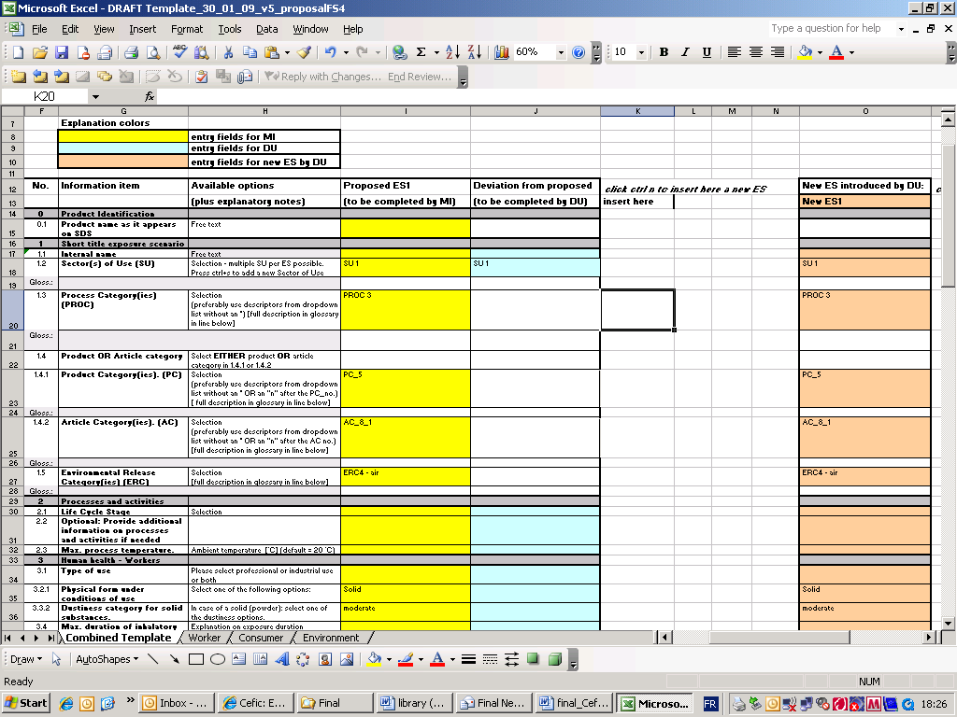 | The MS Excel® template supports the dialogue between a M/I and the DU.  In the first step, the M/I enters all parameters relevant for the ES in the yellow column.  In the second step, the DU checks this proposed ES against his use/exposure conditions.  The DU may provide feedback to the M/I on the proposed ESs. The DU needs to provide feedback only if his use/exposure condition is not or not fully covered. The DU enters these deviations from the proposed ES in the blue column and sends his feedback to the M/I.  A DU may communicate a new use to his supplier by filling the separate pink column.  The template can contain just one activity or task or a set of tasks related to an application.  The template is available in a version for worker exposure or consumer exposure only, or in a combined version (worker plus consumer exposure). Environmental exposure is integrated in both worker as consumer exposure versions.
Figure 1: extract of the Cefic dialogue template for SES building

Steps in the SES development
Figure 2 gives an overview of the steps involved in the SES development process.

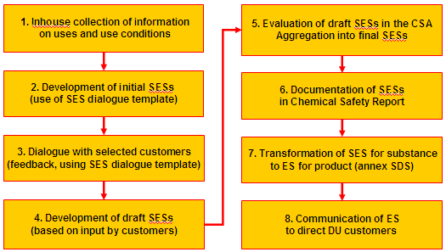
Figure 2: Steps in the Specific Exposure Scenario development process

- Collection of information: the M/I starts with collection of information on uses and use conditions from internal sources for all products containing the relevant substance. Use of a mapping form can be beneficial in this activity, containing information on the following aspects:
- task (e.g. manufacture, loading, storage, processing, maintenance, etc.);
- user type (industrial/professional/consumer);
- task/process details (continuous/batch operation, processes, type of equipment, etc.);
- relevant use descriptors (SU, PC, PROC, AC, ERC) ;
- exposure duration;
- typical RMMs used (e.g. LEV, RPE, PPE).
Some DU associations are also carrying out mappings of uses relevant for their sectors. Such mappings can help the M/I in this first phase.

- Development of initial SESs: the results of the mapping are used to develop initial ES by means of the template in the yellow column (see figure 1). Considering the type of products containing the relevant substance, the type of uses and the assumed level of expertise with DU customers, the combined template (worker + consumer exposure) is used, or the separate templates for worker and consumer use.

- Dialogue with selected customers: based on information on customer characteristics, a limited number of representative customers is selected and approached to provide input on the initial SESs for the products containing the relevant substance. The dialogue with selected customers typically starts with a conference call in which:
- the reasons for the dialogue are explained as well as the intended results;
- a check is made to confirm that the customer is rightly being selected;
- an explanation on the template and the use of the template in the supply chain is given;
- agreements are made on activities and timing. This dialogue should happen in a timely manner, bearing in mind the registration deadline and the communication to the supply chain.
Note: the dialogue can take place in different ways at different stages of the dialogue, depending on opportunities and needs: with each customer separately or with a group of customers; by telephone conferences, in face-to-face meetings or just by email contact.

- Development of draft SESs: depending on the extent and content of the first feedback by customers, a decision has to be taken for continuation of the dialogue in order to gather additional or more specific information or to clarify the input of customers. When the M/I considers the input by customers sufficient, this input is then used to modify the initial SESs into draft SESs for the products. All draft SESs for the products, containing the relevant substance, are then assigned to the relevant substance for further processing in the Chemical Safety Assessment (CSA).

- Evaluation of draft SESs in the CSA: for each draft SES a Tier 1 exposure assessment is performed, using the ECETOC TRA tool. The estimated exposures for worker and consumer and estimated environmental emissions are compared with the relevant DNELs (human exposure: inhalation, skin, oral) and PNECs (environmental emission: air, water, sediment, land) for the substance.
Where safe use is not demonstrated directly (exposure lower than the applicable DNEL or PNEC ), iterations are carried out in the estimation of exposure using the available OC/RMMs in the ECETOC TRA tool. If safe use cannot be demonstrated using a Tier 1 approach, a Tier 2 exposure assessment will be performed, using (a combination of) higher Tier exposure estimation models and available exposure data. This might result in a renewed contact with selected customers to obtain additional information.
After demonstration of safe use, the SESs for separate tasks are as much as possible aggregated into final (composite) SESs. The (composite) SES includes the aggregation of ES where the risk assessment indicates that SESs for separate tasks include equivalent RMMs.

- Documentation in Chemical Safety Report (CSR): all final SESs and the results of the risk assessment are documented for inclusion in the CSR.

- Transformation of SES to ES format: in order to develop an ES for a product, the final SESs for a substance in the SES template format are combined and evaluated with the SESs of other substances in a product to generate an ES for the product in the format for publication as annex to the Safety Data Sheet (SDS). Utilizing information in RMM libraries, the language in the SES will be adapted to more specific industry jargon in the ES to increase readability and facilitate comprehension by DUs.

- Communication to direct DUs: as soon as the available product ESs are available, they are communicated to the direct DUs for communication in the supply chain, pending finalization and submission of the CSR and inclusion within the eSDS.

http://guidance.echa.europa.eu/docs/guidance_document/information_requirements_part_d_en.pdf?vers=20_08_08
Methodology based on the Dangerous Preparations Directive (DPD)
http://guidance.echa.europa.eu/docs/guidance_document/information_requirements_r12_en.pdf?vers=20_08_08
According to the Technical Guidance Document (TGD) on Information Requirements and Chemical Safety Assessment, part D, a Tier 1 assessment aims at estimating the ‘reasonable worst case’ exposure for the conditions of use described in the initial ES. This can be obtained from actual measurements or standard exposure models and where possible, preset conditions of use as defined for certain process or product categories. A Tier 2 assessment, according to the TGD is to be undertaken if control of risk cannot be demonstrated for the initial ES in the Tier 1 process. Tier 2 focuses on typical well-defined exposures with appropriate knowledge on the confidence limits involved, based on uncertainty and variability of the relevant parameters.
http://guidance.echa.europa.eu/docs/guidance_document/information_requirements_r12_en.pdf?vers=20_08_08
http://guidance.echa.europa.eu/docs/guidance_document/du_en.pdf?vers=29_01_08
http://guidance.echa.europa.eu/docs/guidance_document/information_requirements_part_d_en.pdf?vers=20_08_08

